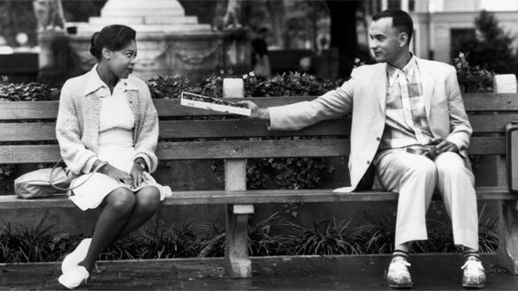

What is Bubba’s real, full name? https://media.giphy.com/media/u29Biz9kyqkFO/giphy.gif

* Benjamin Bubba Blue
* Benjamin Beaufort Blue
* Benjamin Buffa Blue
* Benjamin Buford Blue

What number bus was Forrest supposed to catch to reach Jenny’s house? https://media.giphy.com/media/PHFmJ1YBSjDMs/giphy.gif

* 6
* 9
* 19
* 26

What is Forrest’s IQ? https://media.giphy.com/media/EHbWV5FXHKxMY/giphy.gif

* 65
* 75
* 85
* 155

What is the name of the security guard that Forrest speaks to when he reposrts the Watergate burglary? https://media.giphy.com/media/wRxT9xrYoxw9q/giphy.gif

* Frank Wills
* Luther Willis
* Steve Evans
* Walter Gate

What foods did Forrest use to describe himself and Jenny? https://media.giphy.com/media/kYigEXoyjkkbS/giphy.gif

* Fish & Chips
* Peas & Carrots
* Meat & Potatoes
* Lemons & Limes